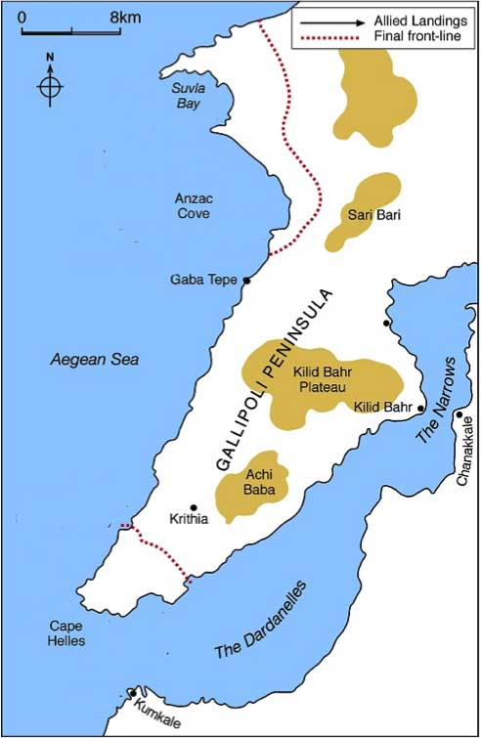
What were the key events of the Gallipoli Campaign April 1915 – January 1916?

